

**Community Transport Outings Program**

**Ferntree Gully- Upper Ferntree Gully | January – April 2025**

Knox residents aged 65+ or those needing transport support can enjoy day outings to various locations across Victoria.

**Cost:** $10.50 per person, invoiced after travel. Entry fees at some venues and meals are at your expense. Cancellations require 24+ hours' notice; otherwise, the trip charge applies.

**Meals:** Morning tea may be available at select venues. Lunch reservations are facilitated, but outside food may not be permitted at certain venues.

**Pick up:** From 9:00am onwards:

|  |  |
| --- | --- |
| Stop 1 | Hutton Avenue Ferntree Gully |
| Stop 2 | Uniting Church 6 The Avenue Ferntree Gully |
| Stop 3 | Mountain Gate Shopping Centre (on public toilet side) |

**Bookings:** Call 9298 8518 (9:00 am–4:30 pm) from **08/01/2025** to provide your wish list, or email your name, suburb, phone number, and wish list to communitytransport@knox.vic.gov.au. **Please note that bookings are not confirmed on a first-come, first-served basis.** All wish lists are reviewed, and after careful deliberation, spots are confirmed within two weeks after 08/01/2025 to ensure that bookings are fair and equitable for everyone.

**Additional Information:**

* **Timings:** Approximate and subject to change.
* **Extreme Weather:** Trips may be adjusted with little to no notice if temperatures are expected to exceed 30°C. Trips may also be canceled with short notice if temperatures are expected to exceed 37°C or in the event of severe rain.
* **Walking Levels:**
* **Low Impact*:*** Minimal walking required.
* **Moderate Impact:**Moderate walking involved*.*
* **High Impact*:*** Significant walking required.

Participants are responsible for assessing their own fitness levels and choosing outings that align with their abilities. While we make every effort to accurately describe the walking requirements, individual experiences may vary.

**Enjoy safe and accessible outings with our community transport service!**

**Tuesday 04 Feb - 9:00am- 3:00pm | Low impact**

**Yakult Factory Tour & Dandenong Market**

Start with a fascinating guided tour of the Yakult Factory to learn about the production of this iconic probiotic drink. Then, enjoy free time at the bustling Dandenong Market, where you can explore fresh produce, unique stalls, and multicultural delights.

**Guided factory tour free. Lunch- Open choice @ Dandenong Market**

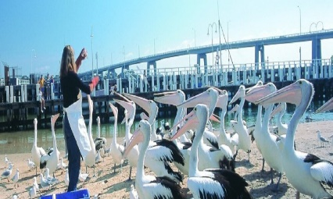 **Tuesday 18 Feb - 9:00am- 3:30pm | Low impact**

**San Remo**Stroll along the picturesque foreshore of San Remo, enjoy fresh seafood at local cafes, or soak in the serene views of Western Port Bay. Outing highlight- daily pelican feeding at 12:00 pm.

**Lunch- Open Choice**

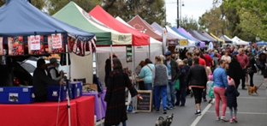**Wednesday 05 Mar - 9:00am- 3:30pm |Moderate impact**

**Mornington Market**  
Mornington Market, is a bustling hub of creativity and community. It’s the perfect place to shop, wander, and soak up the lively atmosphere.

**Lunch- Open Choice**

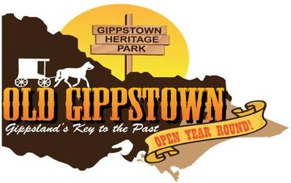**Friday 14 March - 9:00am- 3:30pm | High impact   
Old Gippstown**   
  
Old Gippstown, showcases an impressive collection of original and replica buildings, including a general store, blacksmith, and schoolhouse, making it a perfect spot to experience Victoria’s past in an engaging and interactive way.

**Seniors $14- Guided tour (including admission); Concession- $12 admission (no guided tour). Lunch- Old Gippstown Café**

**Monday 24 Mar- 9:00am- 3:30pm | Low impact**

**Mystery Tour**Embark on a mystery drive to the picturesque village in Melbourne, where every twist and turn reveals a new surprise. Enjoy your journey by weaving through lush countryside, past rolling vineyards and fragrant orchards.

**Lunch- Mystery Location. Seniors’ menu may be available.**

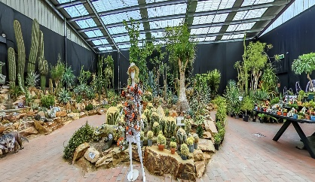**Wednesday 02 April- 9:00am- 3:30pm | Low impact**

**Collector’s Corner**  
Collector's Corner, is a unique destination that offers an incredible array of collectibles, including rare plants like cacti, bonsai, and succulents, alongside gemstones, fossils, and other natural wonders.

**Lunch at Garden World Café.**